Report
I have built a prototype of a customer management system that can be easily scaled to support multiple platforms. To make this possible, I used the Model-View-Controller pattern. It separates the program into basic parts, which makes it easy to update and fix later. The model keeps customer data, and the user interface using Windows Form displays the data to the customer. The controller class is made which handles all the logic between data and user interface. The diagram shows that the CustomerView is the form where the user clicks buttons to add, edit, or delete customers and Customer Data like id and name is managed in the model (Customer.cs). The CustomerManager is the controller that handles all the logic and talks to the data class. The arrows show that the view calls the controller, and the controller manages the data.
Controller Class Diagram
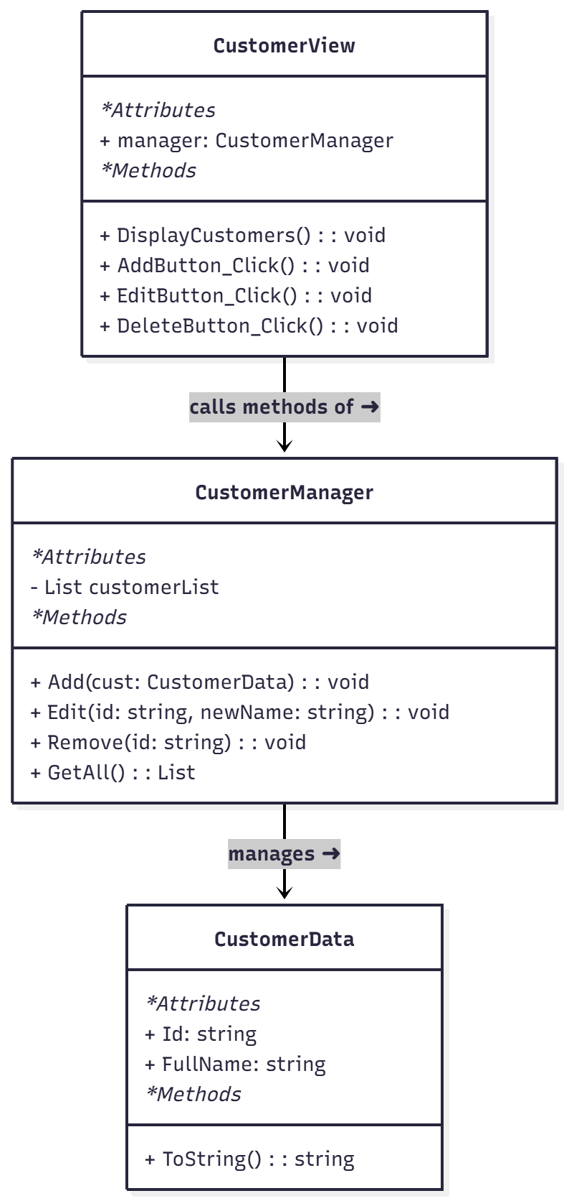
This makes the app easy to update and reuse later for web or mobile versions. The main logic is written in the CustomerManager class which controls how the program adds, edits, and deletes customer records. It has a list which works like a small database for the app. The method Add() puts new customers after checking that fields are not blank. Edit() finds the correct record and changes the name if it exists. Remove() deletes the record from the list, and GetAll() returns all customers back to the form. The methods are designed to run simple checks and errors and flash basic error messages if the inputs are invalid.
This design works well because the form does not hold any logic. The controller talks to the model, and the customer view form only displays the information. The MVC rules are applied and the model can be used with other platforms also.

